Preparation for the Easter Holidays
In preparation for an increase in visitor numbers to our resort areas now that some restrictions have lifted our resort and cleansing teams have been busy ensuring that people can visit safely.

- COVID Cleaning tender – awarded and been in place since start of March, this includes main Play Area in the Esplanade gardens, all benches, railings on seafront, gardens, the green & Cliff Top. This is completed daily and runs initially for 6 months (they also clean Walks and areas in Kings Lynn & BCKLWN playgrounds – frequency depends on usage)
- Toilet Blocks – Would normally open 1st April, but due to nice weather were opened earlier this week. Blocks fully open & ready for use
- Hand Wash sinks – all operational – located Heacham North & South Beach, Central Promenade, the green/Esplanade & The Cliff Top Car Park – Cleansing team replenish supplies as part of toilet checks
- Hands face Space – floor Stickers in place on main entrance routes to the seafront. Signs at key points displaying the same message to be installed today.
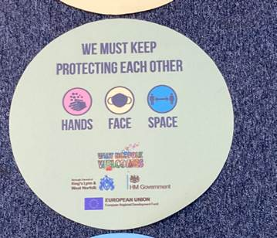
- Beach Patrol/ Seafront Staff – Started 29th March, role to offer help, support & guidance to users of the seafront
- First aid provision – Medic with response car to be sited on seafront from 1st April to 11th April
- COVID Marshals – Have been tasked to spend extra time in the Resort areas this weekend.
- Event Board – Hands Face, Space message – being printed – should be ready for display today
- Seasonal Amenities (Crazy Golf, Putting, Footgolf & Pitch & Putt) all open with safe systems of work in place.
- Additional hands, face, space signs are being printed and attached to correx if necessary.

Alive Leisure outdoor facilities
In accordance with the change in guidance, Alive Leisure have reopened some of their outdoor facilities. They will be issuing a press release in due course and this will be shared.

Explore-a-bench book bench trail
An exciting trail of ten colourful book benches has been launched, which people can safely visit. More details are here Explore-a-book bench trail launches | Borough Council of King's Lynn & West Norfolk (west-norfolk.gov.uk).

Social media messages
Our social media messaging has focused around advising people to be respectful if they are visiting the coast, to follow the guidance around hands, face, space, to plan ahead and to travel at less busy times. We are also urging people to take their rubbish home with them.

Useful numbers
As stated in previous briefings, any concerns about the behaviour or individuals or groups of people should reported to the police using their 101 non-emergency number.
Concerns about businesses operating outside of the current guidance should be reported to the council using the online form Report a breach or star of COVID-19 safety rules | Report a breach or star of COVID-19 safety rules | Borough Council of King's Lynn & West Norfolk (west-norfolk.gov.uk).

